ACHIEVERS’ JUNIOR ACADEMY
P4 SCIENCE NOTES
TERM2 2013

WEEK TWO
LESSON ONE

OUR FOOD

VOCABULARY
- Food
- hunger
- healthy
- habit
- hospitality
- happiness

Food is anything we eat or drink to get energy, be healthy and build our bodies.
Nutrition is the process of taking in and using food in the body.

Uses of food to the body.
- Food provides energy to the body
- Food keeps the body healthy
- Food builds the body
- Food provides warmth to the body.

Why we eat food

We eat food every day for the following reasons;
- To satisfy hunger
- To be healthy
- Because it is a habit
- Because of hospitality
- Because of happiness.
Note: The above reasons are known as the 5Hs, that is,

- Hunger (because our stomachs feel empty)
- Health (because we know that we need food and drink in order to live)
- Habit (because it is the time of day when we normally out)
- Happiness (because we enjoy eating certain foods)
- Hospitality (because we have guests and it is our custom to offer them food)

Ways people get food
- By growing it in the garden
- By buying it from the shops/markets.
- By fishing from lakes, swamps, rivers.
- By hunting
- By gathering from forests and bushes.

Places where people get food
- From shops
- From the garden
- From the supermarket
- From markets
- From lakes, rivers, swamps, etc
- From forests

ACTIVITY
- Briefly explain nutrition
- How is food useful in the body?
- Why do people eat food?
- How do people get food?

LESSON TWO

VOCABULARY
- Classes of food
- food values
- proteins

Note: Go, Grow and Glow foods are known as the 3Gs, that is
- Go foods
- Grow foods
- Glow foods

Classes of food/food values:

Sorting sources
(Practical lesson on animal plant proteins)

They are;
- Proteins
- Carbohydrates
- Vitamins
- Fats and oils
- Minerals

PROTEINS
Uses;
These are body building food values.
- They make new cells in the body.
- They repair worn out cells// replace worn out cells.
Sources of proteins
- Animal proteins
- Beef
- Chicken
- Fish
- Eggs
- Milk
- Grasshoppers
- White ants
- Pork

- Plant protein
- Beans
- Soya beans
- Ground nuts
- Peas
ACTIVITY:
- List down any two classes of food.
- How are proteins important in the body?
- Identify any one example of the following:
- Animal proteins
- Plant proteins

LESSON THREE

CARBOHYDRATES

VOCABULARY
- Carbohydrates
- energy
- source

Uses:

These are energy giving food values.
They provide energy to the body.

Sources of carbohydrates
- Maize
- Millet
- Cassava
- Rice
- Sorghum
- Sweet potatoes
- Irish potatoes
- Coco yams
- Matooke
- Sugar cane
ACTIVITY:
- How are carbohydrates useful to an athlete?
- Identify any one example of foodstuff suitable for a footballer.
- Why should people be encouraged to eat foods rich in vitamins?
LESSON FOUR AND FIVE

VITAMINS

VOCABULARY
- Vitamins
- immunity
- source
They are health giving foods:
They increase body immunity
Types of vitamins
- Vitamin A
- Vitamin B1
- Vitamin B2
- Vitamin C
- Vitamin D

Uses of Vitamins
Vitamin/ mineral | Sources | Importance | Deficiency | Signs /symptoms
Vitamin A | - Liver  - Cheese  - Butter  - Margarine  - Milk  - Eggs  - Spinach  - Carrots  - Red palm oil | - Increases resistance to diseases.  - For god night vision | - (night blindness) | - Blurred objects  - Poor eye sight  - Reduced night vision.
Vitamin B1 | - Unpolished cereals  - Beans  - Groundnuts  - Green vegetables  - Meat  - Yeast | - For mental health  - For proper growth | - Beriberi disease | - Poor growth  - Paralysis  - Forgetfulness  - Lack of appetite  - Body weakness
Vitamin B2 | - Beans  - Lean meat  - Liver  - Yeast  - Kidney  - Groundnuts | - For mental health  - For proper growth | - Pellagra | - Body weakness  - Poor growth
Vitamin C | - Oranges  - Lemons  - Guavas  - Tomatoes  - Mangoes  - Pawpaw  - Fresh green vegetables | - For strong skin membranes | - Scurvy | - Bleeding of the gums  - Poor healing of wounds  - Reduced resistance to diseases.  - Poor growth of the skin.
Vitamin D | - Butter  - Milk  - Cheese  - Egg York  - Liver  - Fish liver oil | - For absorption of calcium  - For strong bones and teeth. | - Rickets | - Week bones

ACTIVITY 1:
- Give any one source of vitamin A
- Suggest one importance of Vitamin B to the body.
- Identify the deficiency disease caused due to lack of vitamin B2 in the body.
- Kato has poor night vision. Which deficiency disease is he suffering from?

ACTIVITY 2:
- Name the deficiency disease caused due to lack of Vitamin D in the body.
- How is scurvy prevented in young children?
- Kato’s brother has a bleeding gum and poor healing of wounds. What deficiency disease is he suffering from?

LESSON SIX

FATS AND OILS
VOCABULARY
- source
- Fats and oils
- all sources of fats
: They are energy giving foods.
Sources of fats and oils
- Milk
- Butter
- Cheese
- Egg York
- Ground nuts
- Ground nuts
- Margarine

N.B. Fats are solid while oils are liquids at room temperature

MINERAL SALTS
VACABULARY
- Sources
- mineral salts
- all examples of mineral salts.
Use:
They are health giving foods.

EXAMPLES OF MINERAL SALTS
- Iron
- Calcium
- Phosphorus
- Iodine
- Sodium
- Potassium
- Magnesium

IRON:
Use: For making red blood cells.

Sources of Iron
- Meat
- Green vegetables e.g. spinach
- Liver

CALCIUM
- Beans
- Milk
- Millet
- Green vegetables

N.B. Phosphorus and magnesium also strength bones and teeth.

IODINE
Use:
For proper functioning of the thyroid gland.

Sources of Iodine:
- Sea fish
- Iodised salt

ACTIVITY:
- Give any two sources of fats and oils.
- Identify any one example of a mineral salt.
- How is iron important in the body?

LESSON SEVEN

BALANCED DIET
VOCABULARY
- Balanced diet
- components
- roughages
- fibre
- paristalsis
A meal which has all food values in their right amounts.

Components of a balanced diet
- Proteins
- Carbohydrates
- Fats
- Vitamins
- Water
- Roughages/fibre.

WATER
Uses of water
- Softens food during digestion
- Dissolves digested food for transport by blood.
- Dissolves waster products for transportation to the excretory organs.
- It helps to control body temperature through sweating.

Sources of water in the body.

- Drinking water directly.
- Tea, porridge, milk.
- Juice
- Fruits e.g. mango, oranges and pineapples.
- Soup.

ACTIVITY:
- Briefly explain a balanced diet.
- Give any three components of a balanced diet.
- How is water useful in the body?
- Why is distilled water not recommended for drinking?

WEEK THREE
LESSON ONE

ROUGHAGES (FIBRE)

It is made of plant materials which cannot be digested.

Use:
- Roughages provide grip for the muscles of the alimentary canal to push the food along.
- It adds bulk to the food.
- It enables the muscles of the alimentary canal to grip food and keeps it moving by peristalsis.

NB: Peristalsis is the movement of food along the alimentary canal.

Sources of roughages
- Cereals
- Vegetables
- Fruits

ACTIVITY:
- State the importance of roughages in the body.
- Outline any two sources of roughages.
- Which digestive disorder is experienced due to lack of roughages in the body?
- Briefly explain peristalsis.

LESSON TWO
DEFICIENCY DISEASES

VOCABULARY
- Marasmus
- kwashiorkor
- prevention
- signs
- anaemia
- goitre

Diseases caused by lack of certain food values in the body.

- KWASHIORKOR
- It is caused by lack of enough proteins in the diet.
- Signs of kwashiorkor
- Swollen belly
- Swollen moon face
- Swollen feet and hands.
- Skin rash
- Brown hair

- Prevention
Eat foods rich in proteins.
- MARASMUS

- Cause
It is caused by lack of enough carbohydrates in the diet.

- Signs of marasmus
- Old man’s face
- Pot belly
- Thin body
- Always hungry
- Weaknesses

- Prevention
Eat food rich in carbohydrates.
ACTIVITY:
- Briefly explain deficiency diseases.
- State the cause of kwashiorkor
- Suggest one way of preventing kwashiorkor.
- Name one deficiency disease called due to lack of carbohydrates in the diet.

LESSON THREE

- ANAEMIA
- It is caused by lack of enough iron in the diet.
- It is prevented by eating foods rich in iron, like liver, eggs, cereals and kidney.

- GOITRE
- It is caused by lack of enough iodine in the diet.
- It is prevented by eating foods rich in iodine, like sea foods and iodised salt.

Signs of goiter
- A swelling in the neck.

Activity:
- Briefly explain the term anaemia.
- What causes anaemia?
- Mary has a swelling around the neck. Name the deficiency disease she is suffering from.

LESSON FOUR

PROPER HANDLING OF FOOD

VOCABULARY
- Food handling
- contamination
- food contamination
- eating habits
- food preservation
- food security
Handling of food in a way that prevents it from being contaminated.
Ways of proper handling of food.
- Wash hands before preparing food.
- Wash hands before serving food.
- Wash vegetables and fruits before eating them.
- Prepare food in a clean place.
- Serve food in clean containers.

Importance of proper handling of food
- It prevents food contamination
- It preserves food for future use.
- It protects the food from pests.

ACTIVITY:
- Suggest one proper way of handling food.
- Give one effect of proper handling of food.
- Identify any one disease that can result from poor handling of food.

LESSON FIVE

FOOD CONTAMINATION
The making of food dirty.

Dangers of poor handling of food
- It spreads germs
- It causes the food to go bad
- It may cause food poisoning.

Ways food gets contamination
- Serving food with dirty hands.
- Serving food in dirty utensils.
- Houseflies and cockroaches
- Preparing food in a dirty environment.
- By dust falling on uncovered food.

ACTIVITY:
- Briefly explain the term food contamination.
- Suggest one way food gets contaminated.
- Mention one danger of poor handling of food.

LESSON SIX:

GOOD EATING HABITS
- Wash hands before eating food.
- Sit upright when eating food.
- Chew food properly before swallowing.
- Avoid talking while eating food.
- Chew food when the mouth is closed.

Bad eating habits
- Eating food with unwashed hands.
- Bending/lying down while eating food.
- Swallowing food before chewing it properly.
- Chewing food with an open mouth.
- Putting big lumps in the mouth at one time.

Dangers of bad eating habits.
- Eating food with unwashed hands contaminates food and may lead to diarrhea.
- Bending while eating food interferes with movement of food in the alimentary canal.
- Swallowing food before proper chewing can lead to indigestion. It can also lead to choking.
- Talking when food is in the mouth and spitting food on other people near you.
- Big lumps can lead to indigestion.

ACTIVITY:
- Identify any tow good eating habits.
- Give any two bad eating habits.
- Suggest any two dangers of bad eating habits.

LESSON SEVEN

Practical lesson

FOOD PRESERVATION
The keeping of food free from germs.

Ways of preserving food.
- Sun drying e.g. cassava, e.g. cassava, beans
- Salting e.g. meat
- Smoking e.g. fish
- Tinning/ bottling/ canning
- Freezing e.g. milk
- Refrigerating e.g. oranges, green vegetables, milk
- Roasting e.g. meat
- Boiling and heating
ACTIVITY;
- Briefly explain food preservation.
- State two ways of preserving food.
- Why do we preserve food?

WEEK FOUR
LESSON ONE

FOOD SECURITY
This is when a family / community has enough food for eating all year around.

Food security can be achieved through.
- Growing enough food.
- Proper storage of food.
- Preservation of food.
- Practicing proper farming methods.

Importance of food security
- The family has enough food to eat throughout the year.
- It prevents deficiency diseases in the family.

ACTIVITY;
1. Briefly explain food security.
- State two ways we can achieve food security.
- Suggest one importance of food security.

WEEK FOUR
LESSON TWO AND THREE.

MAJOR ORGANS OF THE BODY

VOCABULARY
- All major body organs
- Diseases
- Disorders

Examples of body organs
- Eye
- Brain
- Ears
- Stomach
- Urinary bladder
- Heart
- Lungs
- Liver
- Kidney
- Skin

Diagram showing the positions of body organs.

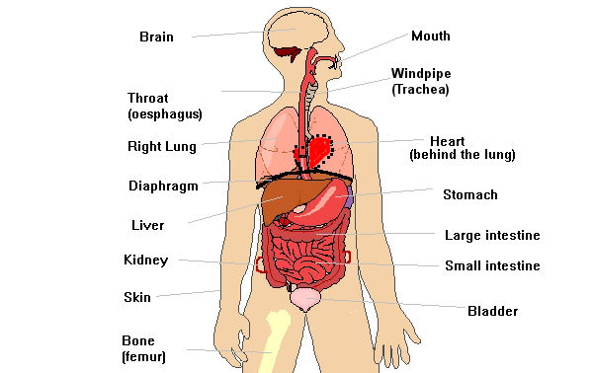

ACTIVITY
- Name atleast two major organs of the human body.
- State the position of the ears on a human body.
- Name the organ of the body which is a sense organ of touch and feeling.
- Name other major sense organs of the body.
- Name the organ that pumps blood to all parts of the body.
- Draw the head part of a human body and locate the ears, eyes and nose.
LESSON FOUR
LESSON FOUR .

The brain
- The brain is found in the head
- The brain is protected by the skull.
Diagram showing the position of the brain

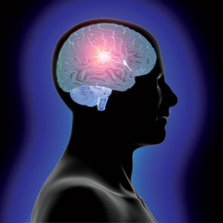

Uses of the brain
- For thinking
- For body balance
- For body balance
- For storing information
- For learning.

Care for the brain
- Having enough rest.
- Avoid drugs like alcohol, marijuana, tabocco.
- Eat a balanced diet.
- Having physical exercises to refresh the brain daily.

ACTIVITY
- State the position of the brain in the human body.
- Name the part of the skeleton that protects the brain.
- Suggest the three uses of the brain to particularly a P.4 child.
- Outline atleast two ways Patrick can care for his brain.
- Name atleast two drugs that are dangerous to the brain.

LESSON FIVE

STOMACH
- It is part of the digestive system
- It stores eaten food for some time.
- The stomach also churns or mixes food to form chime.
- In the stomach, germs in the food are killed by hydrochloric acid produced by the wholes of the stomach.
- Alcohol enters blood in the stomach.

Diagram showing the position of the stomach

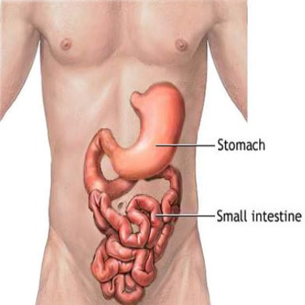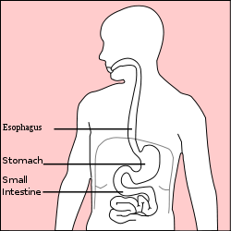

ACTIVITY:
- In which system of the body do we find the stomach?
- Suggest two uses of the stomach to a person.
- Name the stomach content that kills germs in the food one swallows.
- Clearly define the term churning.
Uses of the stomach
- It stores food.
- It digests food
- It produces an acid which kills germs in the food.
Care for the stomach.
- Avoid drinking too much alcohol.
- Drinking a lot of water to prevent constipation.
- Eat a balanced diet
- Avoid smoking.
- Avoid prolonged hunger.

Diseases of the stomach
- Ulcers
- Diarrhea

Disorders of the stomach
- Constipation
- Indigestion
- Vomiting
- Choking

ACTIVITY;
- Suggest two ways one can care for the stomach.
- Name atleast two diseases of the stomach.
- Identify three disorders of the stomach.
- Why is a school student encouraged to drink a lot of water every after a meal?

LESSON SIX

THE EYES

The eyes are found in the head.
Eyes are protected by eye socket found in the skull.
People have two eyes
They are used for seeing.

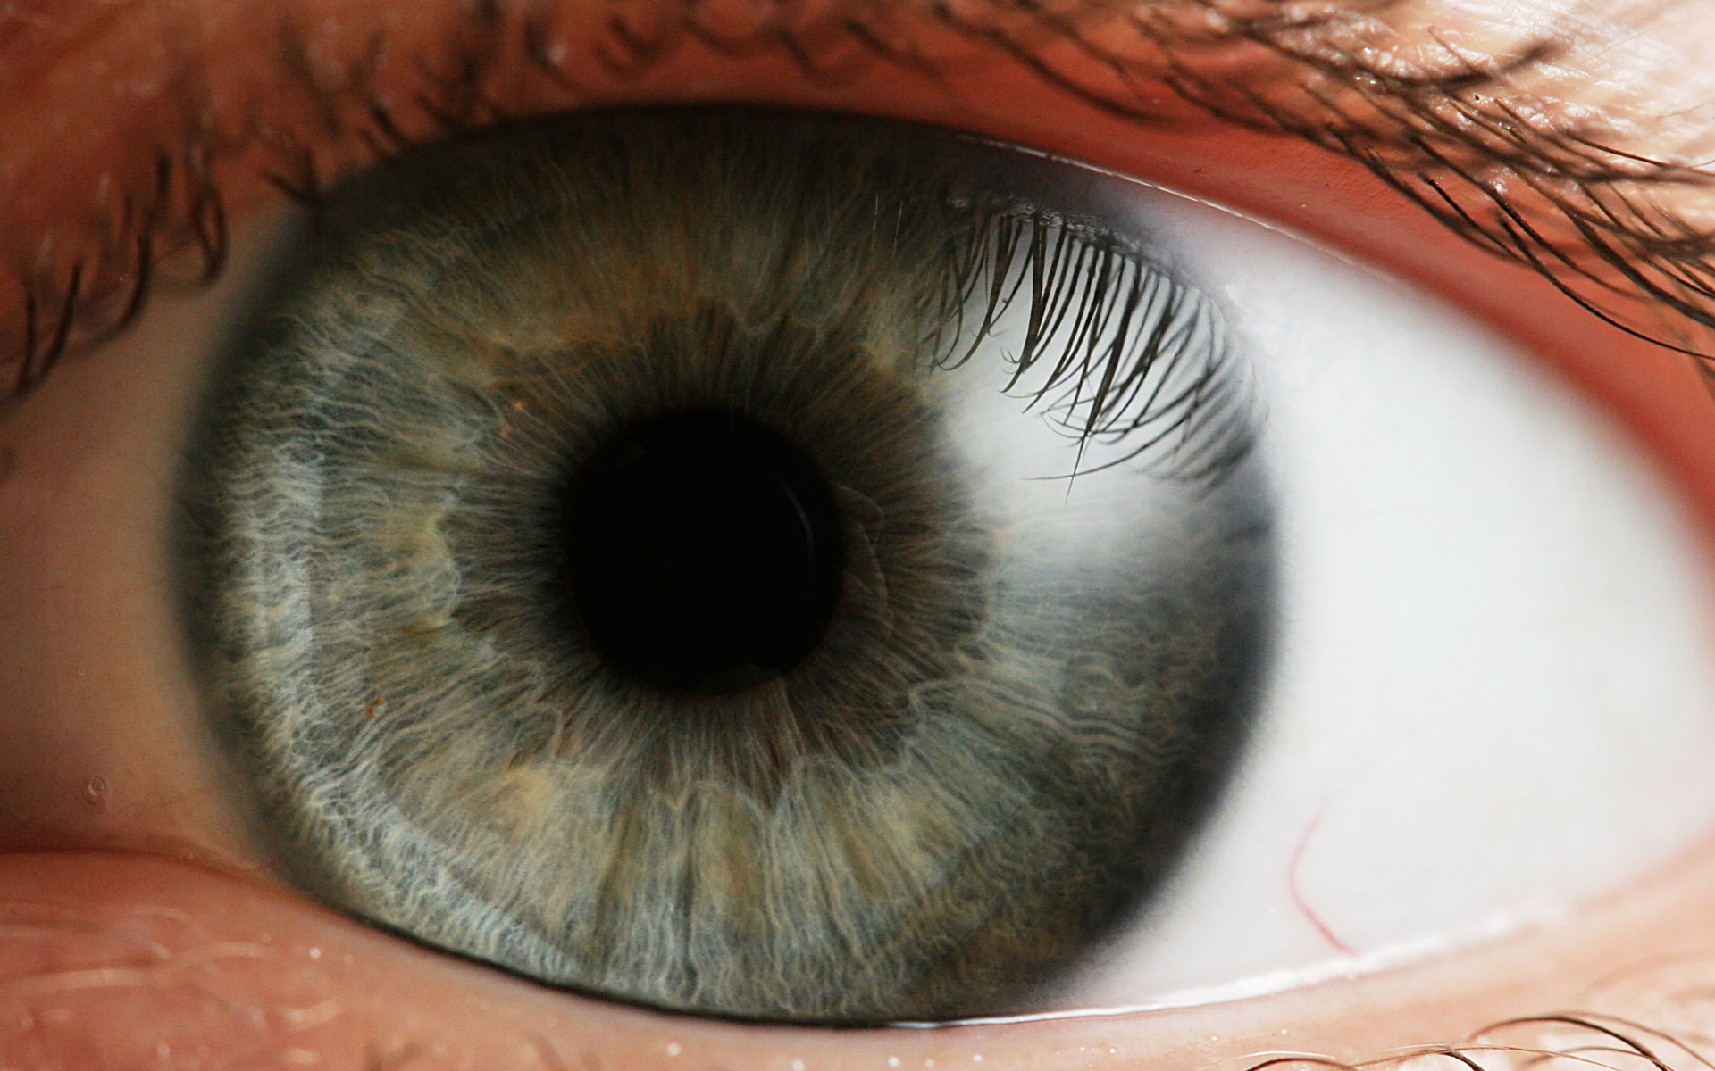

Care for the eyes:
- Wash eyes with soap and clean water regularly.
- Avoid looking at bright light directly.
- Visit eye clinics for regular checkups and tests.
- When reading or writing, do not hold your book too close or far from the eyes.
- Do not strain your eyes by reading in dim light, in a moving car, in direct sunlight, etc.
Diseases of the eyes.
- Trachoma
- River blindness
- Conjunctivitis
- Night blindness.

ACTIVITY
- Name the part of the skeleton that protect the eyes.
- Suggest two ways a student can care for the eyes.
- Identify atleast two diseases of the eyes.
- Of what use is the tear gland in the human eye.

LESSON SEVEN

EARS
- They are found on the head.
- People have two ears at the sides of the head.

Diagram showing the position of the ear

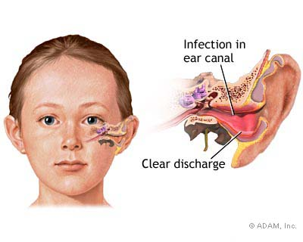

Uses of the ears
- Ears are used for hearing.
- For body balance.

Care for ears
- Wash your ears daily and keep them dry.
- Do not put or push objects into your ears.
- Do not use sharp objects for cleaning your ears.
- Do not direct your ears to loud sound.

ACTIVITY
- What is the position of the ears in a human body?
- Suggest two uses of ears to a good listener?
- Identity three ways to care for our ears.
- Why is the ear referred as a sense organ?

WEEK FIVE
LESSON ONE

THE LIVER
It is located in the upper part of the abdomen.

Uses of the liver
- Regulates blood sugar
- Produces bile
- Stores iron
- Removes poisonous substances from the blood
- Stores Vitamin A and D

Care for the liver
- Avoid drinking too much alcohol
- Have a balanced diet
- Do regular body physical exercises.
Diseases of the liver
- Cirrhosis
- Hepatitis
- Cancer of the liver

ACTIVITY
- The liver is located in the upper part of the abdomen. Of what use is the liver in the body?
- Outline two vitamins stored in the liver for use.
- Cirrhosis attacks the liver. Name two other diseases of the liver.
- Suggest two ways o care for the liver.

LESSON TWO AND THREE
KIDNEYS
- They are found at the back of the abdominal cavity
- There are two kidneys in the human body
- They are protected by the pelvis

Use of the kidneys
They filter blood.

Care for the kidneys
- Regular physical exercise
- Drink plenty of water
- Avoid holding urine for a long time

Disease of kidneys
- Kidney stones
- Bilharzias
- Kidney failure

ACTIVITY;

1. Which part of the skeleton protects the kidney?
2. Give the use of the kidney in the body.
3. Suggest two ways of caring for the kidneys.
4. Mention one disease of the kidneys.

The bladder (Urinary bladder)
- It is found in the lower abdomen.

Diagram showing the position of the urinary bladder and the kidneys.

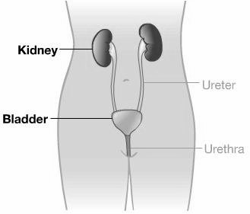

Use of the urinary bladder
- It stores urine

Care for the urinary bladder
- Avoid drinking too much alcohol.
- Do not keep urine for a long time in the bladder.
- Drinking plenty of water.

The gall bladder
- It is found in the liver.
- Its main work is to store bile.

ACTIVITY
- The urinary bladder of a human body is found in the lower abdomen. Of what use is the urinary bladder.
- The main function of the gall bladder is to store the bile. In which organ the gall bladder found in the body.
- The diagram below shows the position of body organs. Label parts K and L.

LESSON FOUR

THE NOSE.
- The nose is found on the head
- A human being has one nose.
- The nose contains hair in it called cilia

The diagram showing the position of the nose.
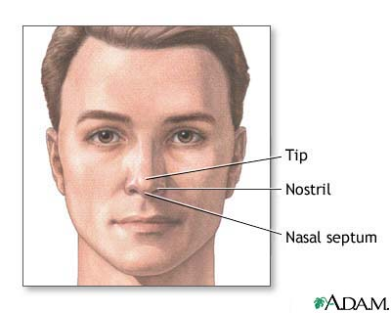

Functions of the nose.
- The nose is used for smelling.
- The nose lets air in and out of the body.
- The cilia helps to trap the dust in the air we breathe in.
- The air is moisten in nose.

Disorders of the nose
- Nose bleeding.
- Nose blockage by the mucus.

How to keep the nose healthy.
- By washing with clean water and soap.
- By cleaning using a clean piece of cloth
- Avoid rough games that might rapture the nose

LESSON FIVE
THE LUNGS.
Diagram showing the position of lungs and the heart.

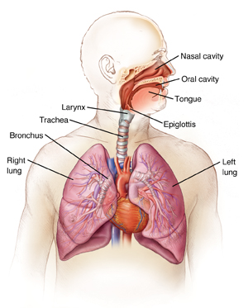

USE OF LUNGS
- For breathing:
- Take in oxygen
- Take out carbon dioxide.

Care of the lungs
- Avoid tobacco smoking
- Avoid dusty places
- Avoid crowded places
- Take infants for immunization to protect them against tuberculosis, whooping cough, etc.
- Do regular physical exercises.
- Isolate people with diseases like tuberculosis.

Diseases of the lungs
- Tuberculosis.
- Diphtheria
- Whooping cough/ pertussis
- Pneumonia
- Influenza
- Chronic bronchitis
ACTIVITY
- Name two body organs which are protected by the rib cage.
- Outline two functions of the human lungs.
- State the three common diseases of the lungs.
- How can a P.4 child prevent the diseases of the lungs?

LESSON SIX
THE HEART
- The heart is situated in the chest cavity.
- It is protected by the rib cage.
- People have one heart.

Use of the heart.
- The heart is used for pumping blood throughout the body.

Care for the heart
- Regular physical exercise.
- Eating a balanced diet
- Avoiding smoking.

Diseases of the heart
- Hypertension
- Heart attack

ACTIVITY;
- Which part of the body protects the heart
- State the function of the heart in the body.
- Suggest two ways of keeping the heart healthy.

LESSON SEVEN

RESPIRATION.
- Respiration is the way the body uses oxygen to break down food in order to produce energy.
- Oxygen is used for respiration
- Respiration takes place in the lungs.
Respiratory organs
- The lungs.
- The nose
- Wind pipe (trachea)
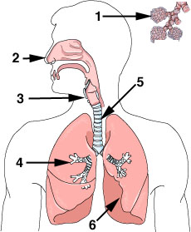

The process of respiration
- The air enters into the body through the nose.
- The air passes through the wind pipe to the lungs.
- In the lungs oxygen joins the blood stream
- The digested food in the stream is then broken down by the oxygen.
NB; breathing is the movement of air in and out of the nose.

Importance of respiration.
- It provides energy to the body
- It helps to remove the waste carbon dioxide from the body.
WEEK SEVEN
LESSON ONE

BLOOD CIRCULATION
- Blood circulation is the movement of blood throughout the body.
- Blood moves through blood vessels in the body.

Organs of blood circulation.
- The heart
- The lungs
- The blood vessels

The process of blood circulation.
- The blood is pumped from the heart to the lungs to pick oxygen.
- The blood flows back to the heart
- The blood is then pumped to all other parts of the body through the blood vessels
- The blood without oxygen flows back to the heart.

Importance of blood circulation
- It transports food nutrients throughout the body.
- It transports waste products to their excretory organs.
- It helps to distributes heat in the body.

LESSON TWO

EXCRETION

THE SKIN
- It is found on the body surface
- It has pores (small openings) on it.
- It has hair on it.

Uses of the skin to people
- Protects the body against external injuries.
- Protects the body against germs.
- Used in the making of Vitamin D.
- The skin regulates body temperature.

Care for the skin:
- Bathing daily to remove germs.
- Do not play rough games that can lead to injury on the skin.
- Put on clean clothes
- Avoid sharing clothes with infected people.

Diseases of the skin:
- Scabies
- Ring worm
- Herpes-zoster
- Athletes foot.

ACTIVITY;
- Mention any two diseases of the kin
- Suggest any two ways of caring for the skin.
- Briefly explain the term excretion.
- Give two uses of a skin.

LESSON THREE

HUMAN TEETH
VOCABULARY
- Set of teeth
- permanent teeth
- milk teeth
- incisors
- canine molars(wisdom teeth)

A tooth is a hard bone-like structure in vertebrates used for breaking food into smaller pieces.

Sets of teeth
- Milk teeth (deciduous teeth)
- Permanent teeth.

N.B: There are 20 milk teeth.
Milk teeth start growing the age of 6 months and at the age of around 7 years, these teeth begin to fall out and are replace by permanent teeth.

Permanent teeth
- This is the second and final set of teeth in mammal’s growth.
- They are the ones that replace the milk teeth.
- A person starts developing permanent teeth at 13 years.
- An adult normal person has 32 permanent teeth consisting of incisors, canines, premolars and molars.

Types of teeth
- Incisors
- Canines
- Molars (wisdom teeth)

Diagram showing a mouth with teeth
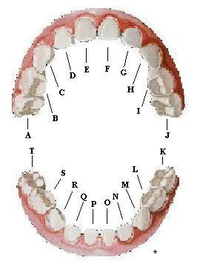
ACTIVITY:
- Name two sets of teeth.
- State the first set of teeth in children.
- How many teeth does an adult have?
- List down two types of teeth.

LESSON FOUR AND FIVE
TYPES OF TEETH
INCISORS
- They are used for cutting and biting food
- They are chisel shaped.

AN INCISOR TOOTH
THE IN TERNAL PARTS OF AN INCISOR TOOTH
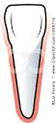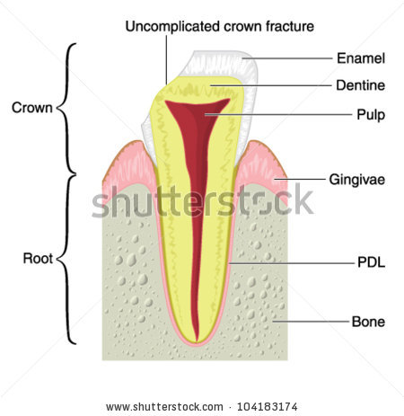

CANINES
- They are used for tearing food.
- They are sharp cone-shaped.

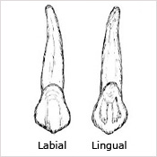

PREMOLARS
- They are used for grinding food.
- They are broad, blunt and flat ridged.

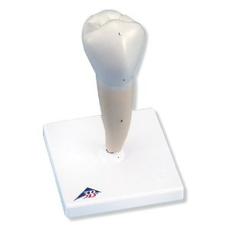

MOLARS
- They are used for grinding and chewing food.
- They are broad, blunt and flat ridged.

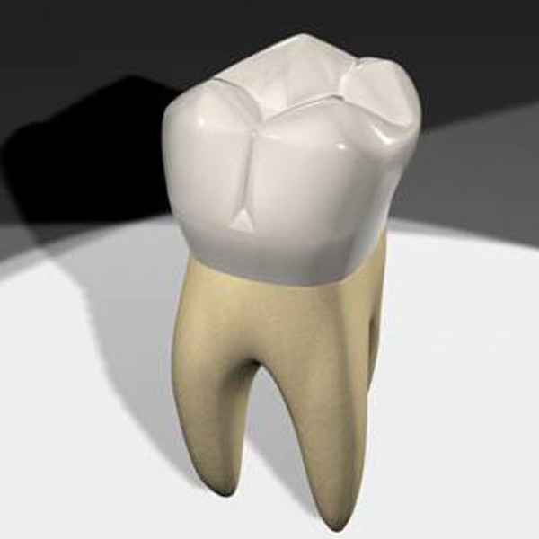

N.B: Dental formula is the arrangement of teeth in the jaws.
ACTIVITY:
- Name two sets of teeth.
- State the first set of teeth in children.
- How many teeth does an adult have?
- List down two types of teeth.

LESSON SIX

THE INTERNAL PARTS OF A TOOTH

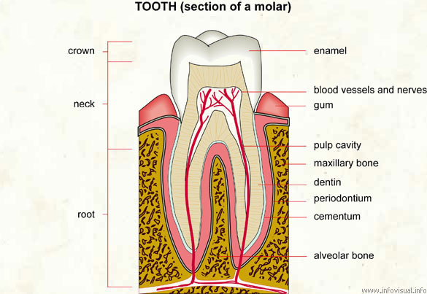

PARTS OF THE TOOTH
VOCABULARY
- Enamel
- Dentine
- Pulp cavity
- Blood capillaries
- Gum
- Cement
- Jaw
- Diseases
- Disorders

ACTIVITY:
- Draw a canine tooth.
- How is an incisor tooth adopted to its function?
- How are molars useful during digestion of food?

LESSON SEVEN

FUNCTIONS OF PARTS OF A TOOTH

ENAMEL
- The hardest part of the tooth.
- It is the hardest substance in the body made up of calcium and phosphorus.
- It prevents wear and tear of the tooth.

DENTINE
- It keeps replacing the enamel as it may wear off due to friction.

PULP CAVITY
- It is the most sensitive part of the tooth.
- It has the blood vessels and sensory nerves.

BLOOD VESSELS
They carry digested food and oxygen to the tooth.

THE SENSORY NERVES
- They are sensitive to heat, pain and cold.
- The tooth begins paining when bacteria destroys the pulp cavity.

CEMENT
It fixes the tooth into the jaw bone.

THE GUM
It gives extra support to the tooth in the jaw bone.
JAW BONE
- It holds the tooth in position
- It protects the tooth.

ACTIVITY:
- Name the hardest part of a tooth.
- Why is the pulp cavity a sensitive part of a tooth?
- Draw a tooth and name the regions.

WEEK EIGHT
LESSON ONE AND TWO
Practical lesson

DISEASES OF THE TEETH
- Tooth decay (dental carries)
- It is caused by bacteria.
- Bacteria acts on sugar and starch, remains on the teeth producing lactic acid that wears and tears the enamel and makes a hole in the dentine and pulp cavity.
- Pain begins when bacteria destroys the pulp cavity.

NB: Dental amalgam (cement) can be used to fill the holes made on the teeth.

- Periodental disease (Gum disease) – This affects the gum.

Disorders of teeth
- Impacted teeth.
- Broken teeth
- Tooth cracks

Disorders of the mouth
- Thrush
- Cancer
- Burning tongue

ACTIVITY:
- Name the two diseases of the teeth.
- Identify atleast two disorders of the teeth.
- Outline two disorders of the mouth.
- Suggest the type of germ that causes dental carries.
- Of what use is dental amalgam to a person whose teeth has holes.

CARE OF OUR TEETH (DENTAL HYGIENE)
- Brush the teeth after every meal.
- Avoid drinking very hot and cold things.
- Avoid eating too many sweets.
- Rinse your mouth with water and salt after every meal.
- Eat plenty of fresh fruits and vegetables.
- Visit a dentist regularly for checkups.
- Eat a balanced diet.

Things we use for brushing teeth.
- Tooth brush
- Tooth paste
- Clean water
- Small sticks

How to brush our teeth
- Brushing teeth should be up and down movement of the tooth brush but not sideways.
- Then clean tooth brush and keep it in a container.

N.B: We brush our teeth regularly to;

i) prevent tooth decay
ii) prevent bad breath
ACTIVITY
- Suggest two ways to care for our teeth.
- Name atleast three material we use for brushing our teeth.
- Why is David, a school boy advised to brush his teeth regularly?
- Why is it advisable for children to avoid eating too much sweets.

LESSON THREE

SANITATION

- The general cleanliness of our environment
- The way we keep our environment clean.

Importance of sanitation
- Prevents the spread of germs.
- Promotes good health in the community.

Activities under sanitation
- Sweeping the compound, house, etc.
- Moping the house, classroom
- Slashing bushes around our homes, school, road sides, water sources.
- Picking and burning rubbish.
- Proper disposal of faeces and urine.
- Draining stagnant water around our homes, school.
- Dusting tables, chairs
- Removing cobwebs from the kitchen, latrines and houses.
- Digging water channels along the roads, in school and home compounds.

Items used in keeping proper sanitation

- Brooms
- Rake
- Mop/rag
- Water
- Soap
- Slasher
- Bins
- Waste basket
- Rubbish pit
- Scrubber
- Spade
- Dryer

LESSON FOUR

GERMS
A germ is an organism that causes diseases.

Types of germs
- Virus
- Bacteria
- Worms
- Protozoa
- Fungi

Where germs are found
- Faeces and urine
- Water
- Soil
- Air
- Under dirty long finger nails
- On dirty clothes
- On dirty beddings

N.B. Germs are found everywhere.

How germs enter our bodies
- Through eating contaminated food
- Through the nose when we breathe in
- Through open wounds and cuts
- Through skin contact with infected persons
- Through sharing clothes with an infected person
- Through vectors

LESSON FIVE

THE 4FS
It is the path of germs from faeces to the inside of our bodies.
It stands for;
- Faeces
- Flies
- Fingers
- Food

Control of the spreading of germs
- Boil water for drinking
- Wash hands before eating food.
- Wash hands after visiting a toilet.
- Destroy the breeding places of vectors by clearing bushes, draining stagnant waters, etc.
- Kill the vectors by spraying
- Prepare food in a clean place
- Cover food
- Have proper disposal of faeces and urine
- Have proper disposal of garbage
- Give health education to the people
- Have all children immunized.

LESSON SIX

ROTTING/DECAY
Meaning
The breakdown of organic matter by bacteria.
It destroys garbage heaps It requires warmth, darkness and moisture.
Importance of rotting/decay

- It destroys faeces in latrines and sewerage systems
- It produces humus from dead organic matter.

Dangers of rotting/decay
- Rotting produces a bad smell
- Rotting matter is a source of germs
- Rotting causes wounds to be septic.

LESSON SEVEN
- Common diseases caused by germs
Diseases | Causative germ
- Trachoma | Bacteria
- Red eyes | Bacteria
- Cholera | Bacteria
- Typhoid | Bacteria
- Dysentery | Bacteria /Amoeba
- Diarrhea | Bacteria / Virus
- Ring worm | Fungus
- Chicken pox | Virus
- Diphtheria | Bacteria
- Pneumonia | Bacteria
- Tetanus | Bacteria
- Measles | Virus
- Polio | Virus
- Whooping cough (pertussis) | Bacteria
- Scabies | Itch mite
- Malaria | Plasmodium (protozoa)
- Sleeping sickness | Trypanosome (protozoa)
- Rabies | Virus
- Typhus fever | Ricketsia
TOPICAL QUESTIONS

- Briefly explain the term sanitation.
_____________________________________________________________
_____________________________________________________________
- Why is sanitation important?
__________________________________________________________________________________________________________________________
- Name four items used in keeping sanitation.
- _____________________________________________________________
- ____________________________________________________________
- ____________________________________________________________
- ____________________________________________________________
- Identify four ways of keeping sanitation.
- _____________________________________________________________
- ____________________________________________________________
- ____________________________________________________________
- ____________________________________________________________
- Write the 4Fs in full.
- _____________________________________________________________
- ____________________________________________________________
- ____________________________________________________________
- ____________________________________________________________
- Mention four examples of germs.
- _____________________________________________________________
- ____________________________________________________________
- ____________________________________________________________
- ____________________________________________________________

- How do germs spread? Give three ways.
- _____________________________________________________________
- ____________________________________________________________
- ____________________________________________________________
- Where do germs breed? Name two
__________________________________________________________________________________________________________________________
- Suggest four ways germs can be controlled.
- _____________________________________________________________
- ____________________________________________________________
- ____________________________________________________________
- ____________________________________________________________
- Give two uses of bacteria in our environment.
__________________________________________________________________________________________________________________________
- In which ways is rotting bad in our environment.
__________________________________________________________________________________________________________________________

TOPICAL QUESTIONS

- Briefly explain the term skeleton.
_____________________________________________________________
- Identify the longest bone in the body.
_____________________________________________________________
- State the difference between a tendon and a ligament.
_____________________________________________________________
- Mention any one example of a ball and socket joint.
_____________________________________________________________
- How is physical exercise useful to our bodies?
_____________________________________________________________
- How is bad body posture dangerous to our bodies?
_____________________________________________________________
- State any one diseases of the skeletal muscular system.
_____________________________________________________________
- What is a joint?
_____________________________________________________________
- State one use of teeth in your mouth.
_____________________________________________________________
- List down four types of teeth.
- _____________________________________________________________
- ____________________________________________________________
- ____________________________________________________________
- ____________________________________________________________
- Give two reasons for brushing teeth.
- _____________________________________________________________
- ____________________________________________________________
- Mention two ways of caring for our teeth.
- _____________________________________________________________
- ____________________________________________________________
- Match the following organs with their work or functions.

Organ Use
- Ears for seeing
- Heart for thinking
- Eyes for pumping blood
- Brain for hearing

- _____________________________________________________________
- ____________________________________________________________
- ____________________________________________________________
- ____________________________________________________________

